**Q.2. Practice the beginners commands for HDFS from the below link https://acadgild.com/blog/hdfs-commands-for-beginners/**

**Ans.**

**1. Put Command**

The ‘put’command feeds the data in to the HDFS.

Syntax:**hadoop dfs –put </source path> </destination path>**

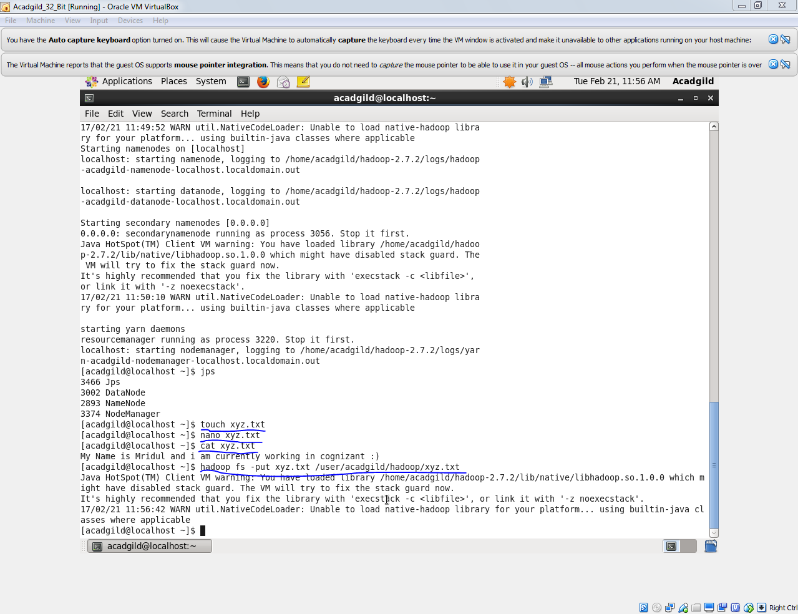

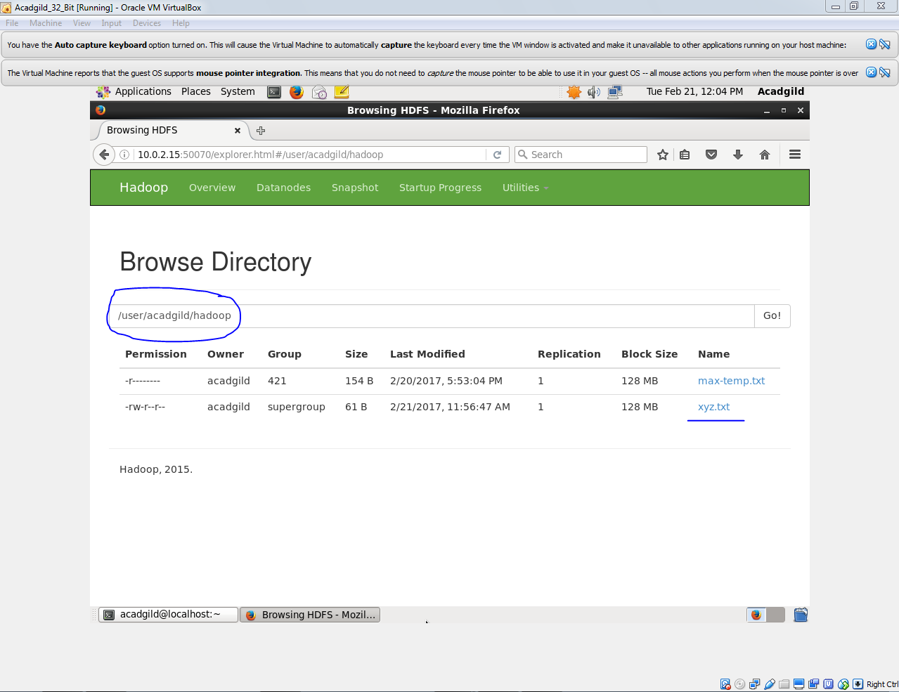

**2. List Command**

The ‘list’command displays all the available files inside a particular path.

Syntax:**hadoop dfs –ls </source path>**

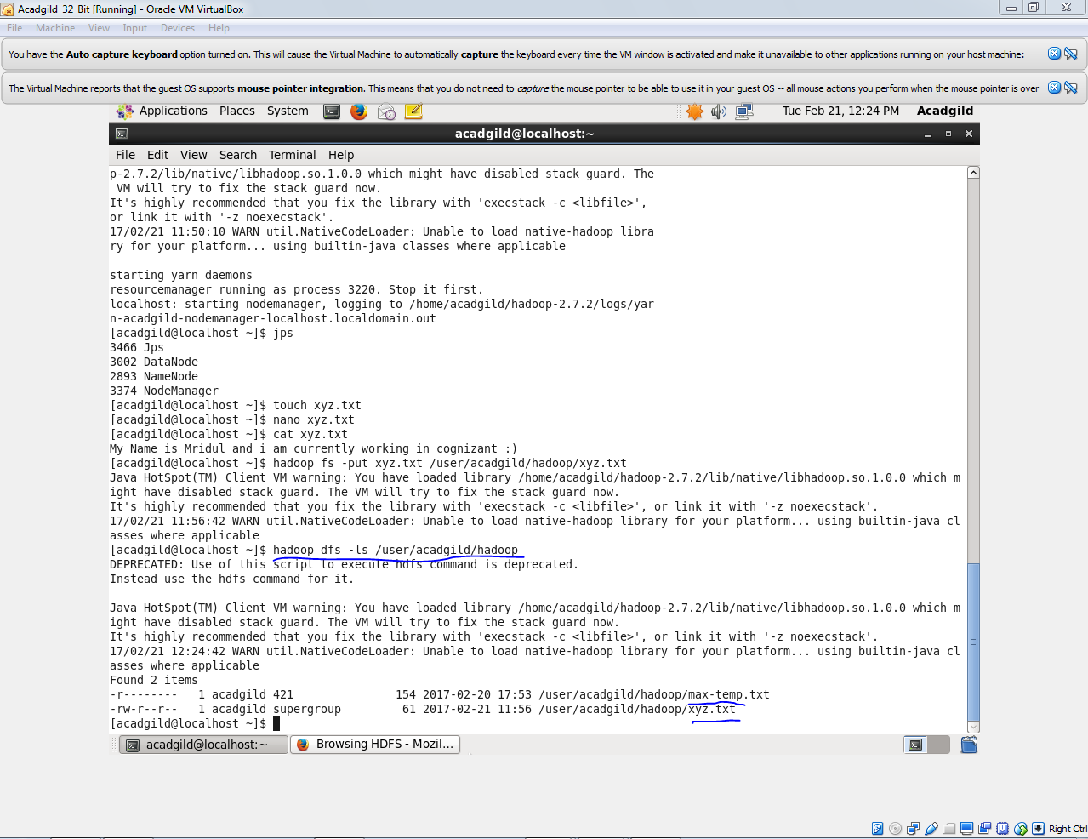

**3.Get Command**

The ‘get’ command copies the entire contents of the mentioned file to the local drive.

Syntax: **hadoop dfs –get </source path> </destination path>**

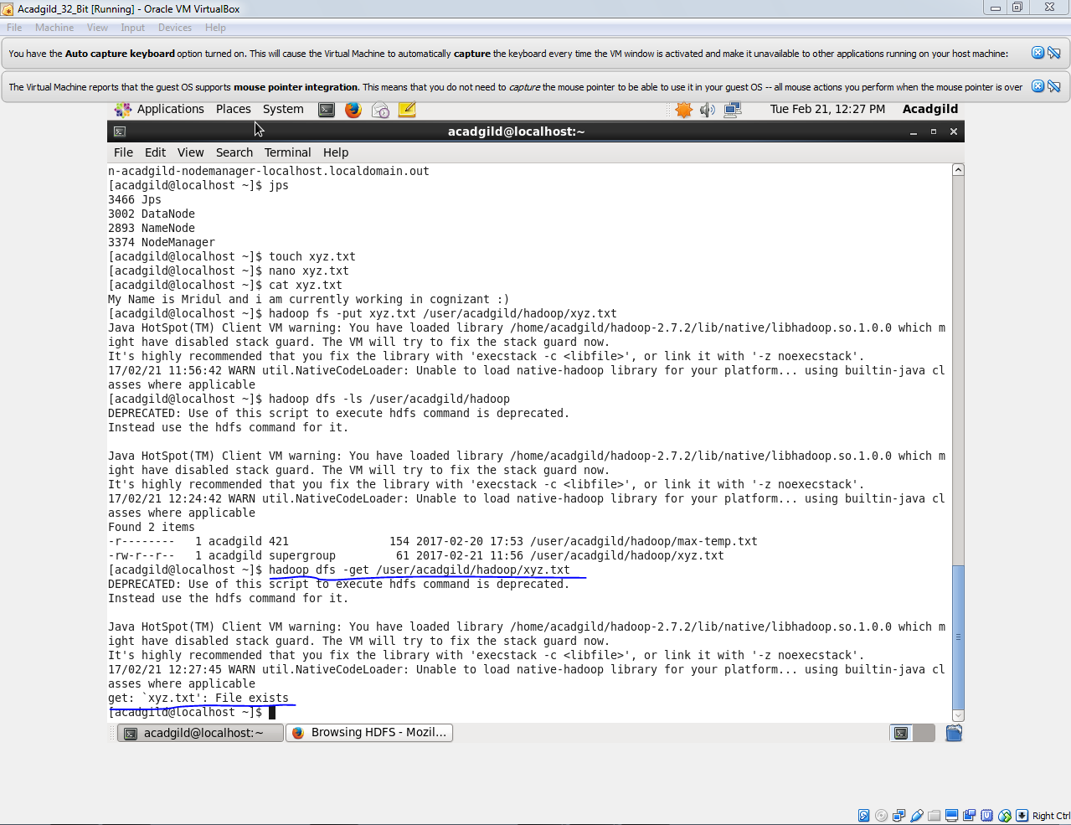

**4. Make Directory Command**

The ‘mkdir’ command creates a new directory in the specified location.

Syntax:**hadoop dfs –mkdir </source path>**

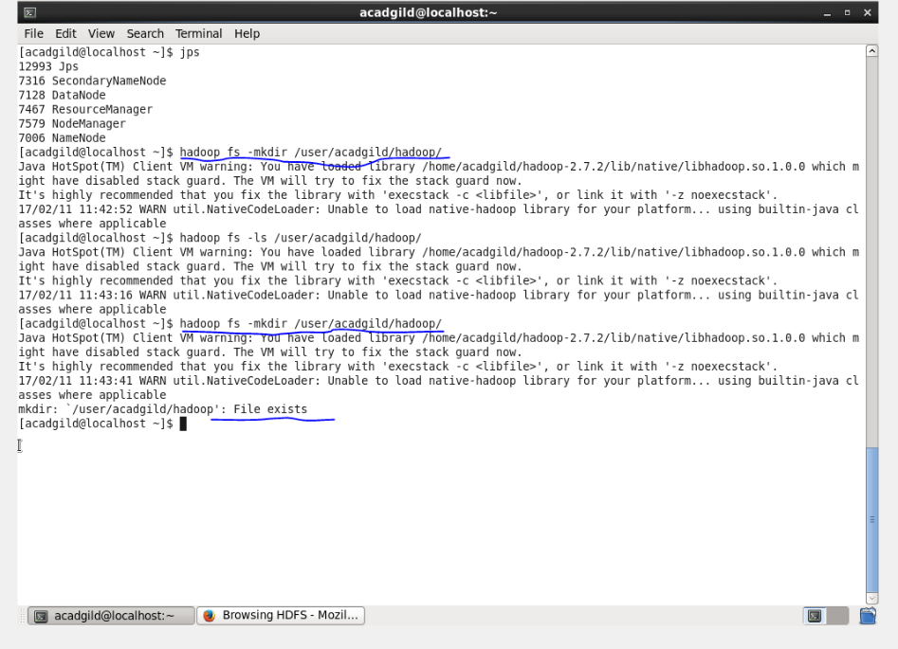

**5. View contents of particular file**

The ‘cat’ command is used to display all the contents of a file.

Syntax:**hadoop dfs –cat </path[filename]>**

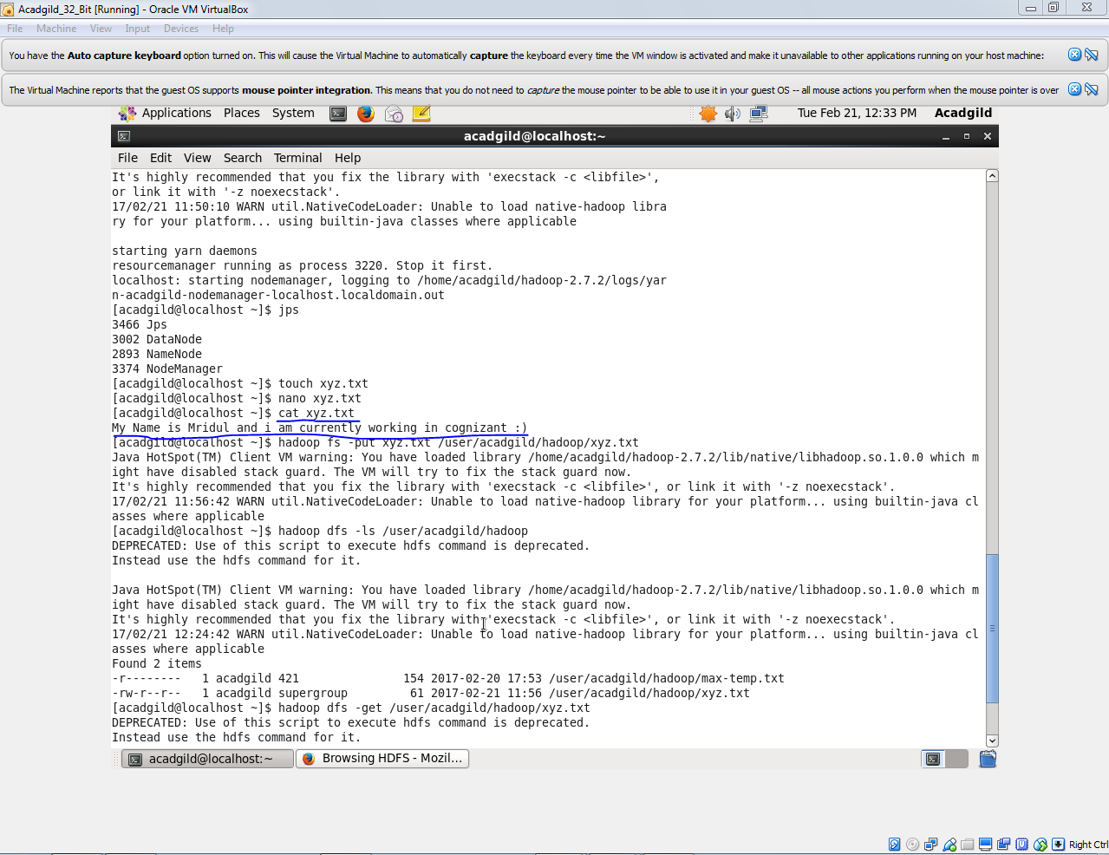

**6.Duplicating a Complete File inside the HDFS.**

The ‘copyfromlocal’ command will copy file from the local file system to the HDFS.

Syntax:**hadoop dfs –copyFromLocal </source path> </destination path>**

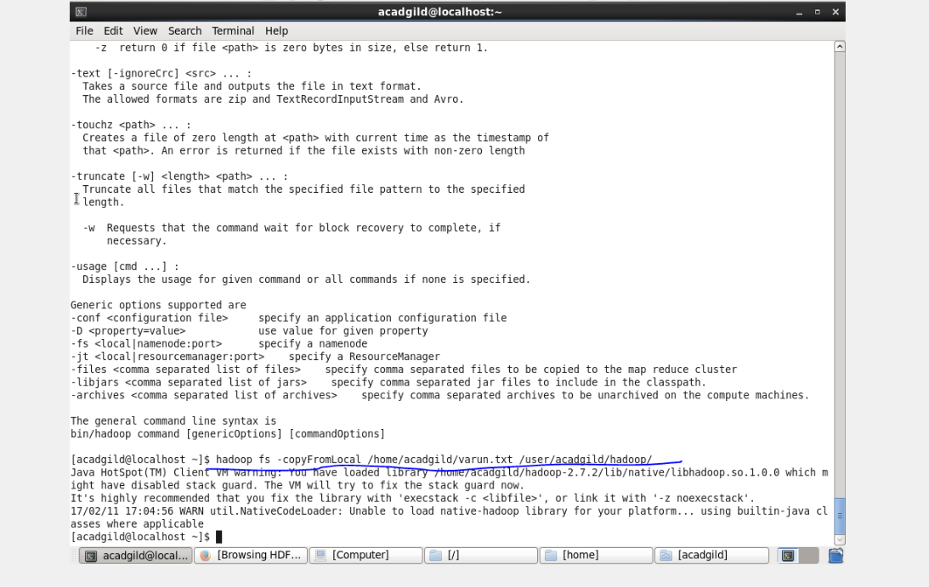

**7.Duplicating a File from HDFS to the Local File System.**

The ‘copytolocal’ command will copy files from the HDFS to the local file system.

Syntax: **hadoop dfs –copyToLocal </source path> </destination path>**

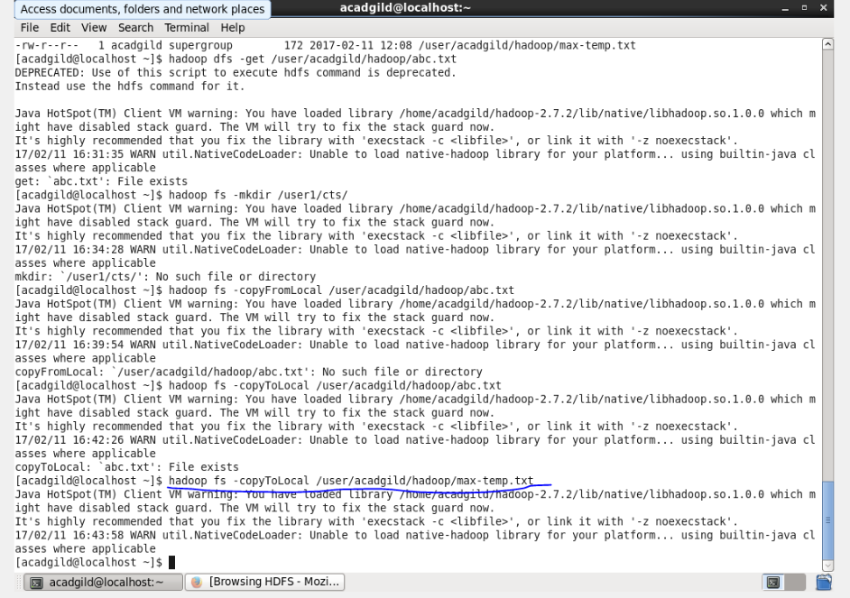

**8.Removing the File**

The command ‘rm’ will delete the file stored inside the HDFS.

Syntax: **hadoop dfs –rm </path[filename]>**

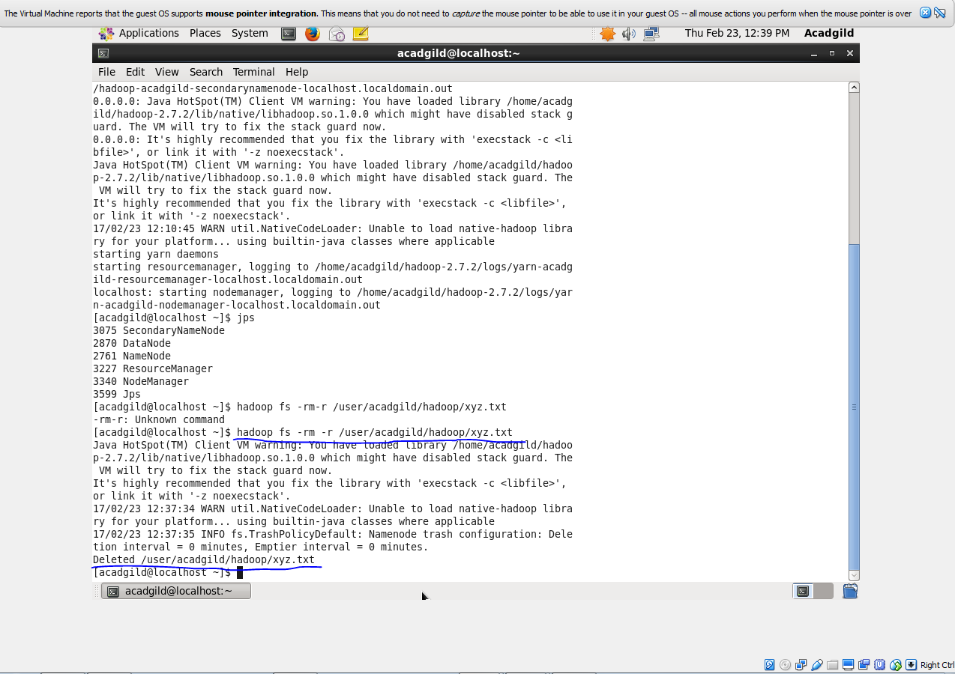

**9.Run a DFS Filesystem to Check Utility**

The command ‘fsck’ is used for checking the consistency of a file system  
Syntax: hadoop fsck </file path>

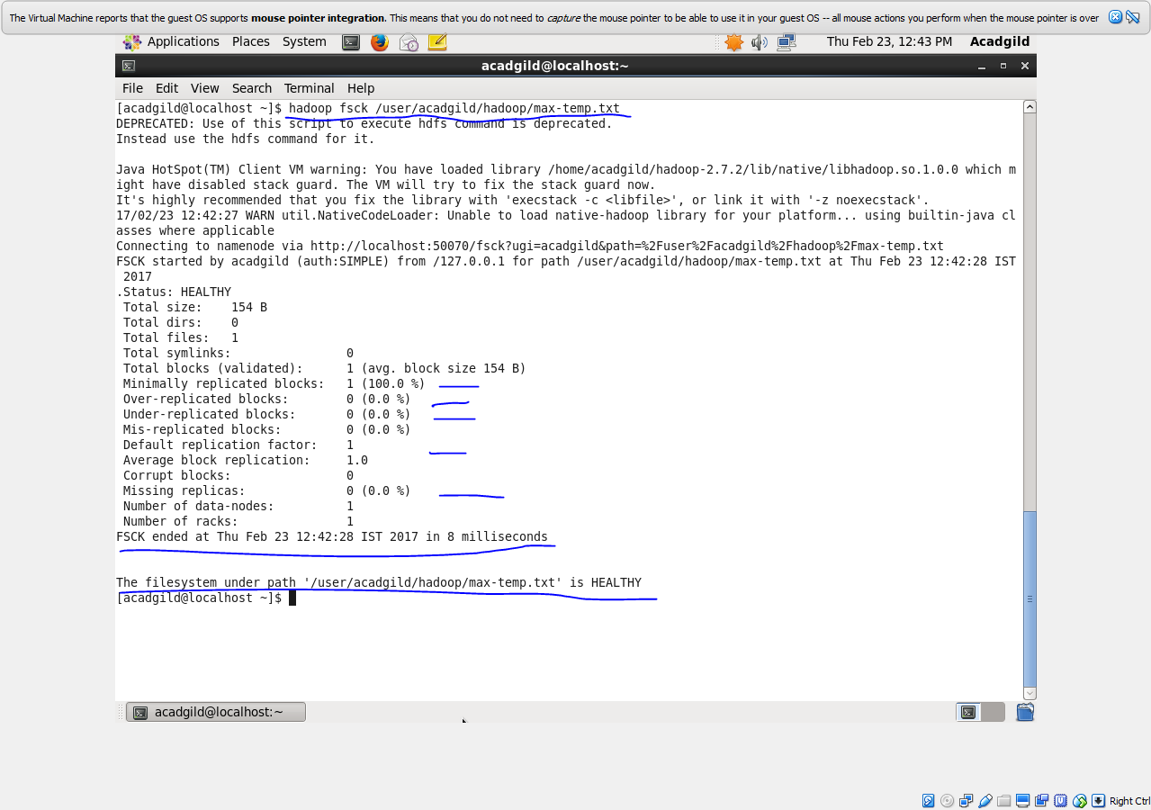

**10.Run a Cluster Balancing Utility**

The command ‘balancer’ will check for work load on nodes in cluster and balance it.  
Syntax: **hadoop balancer**

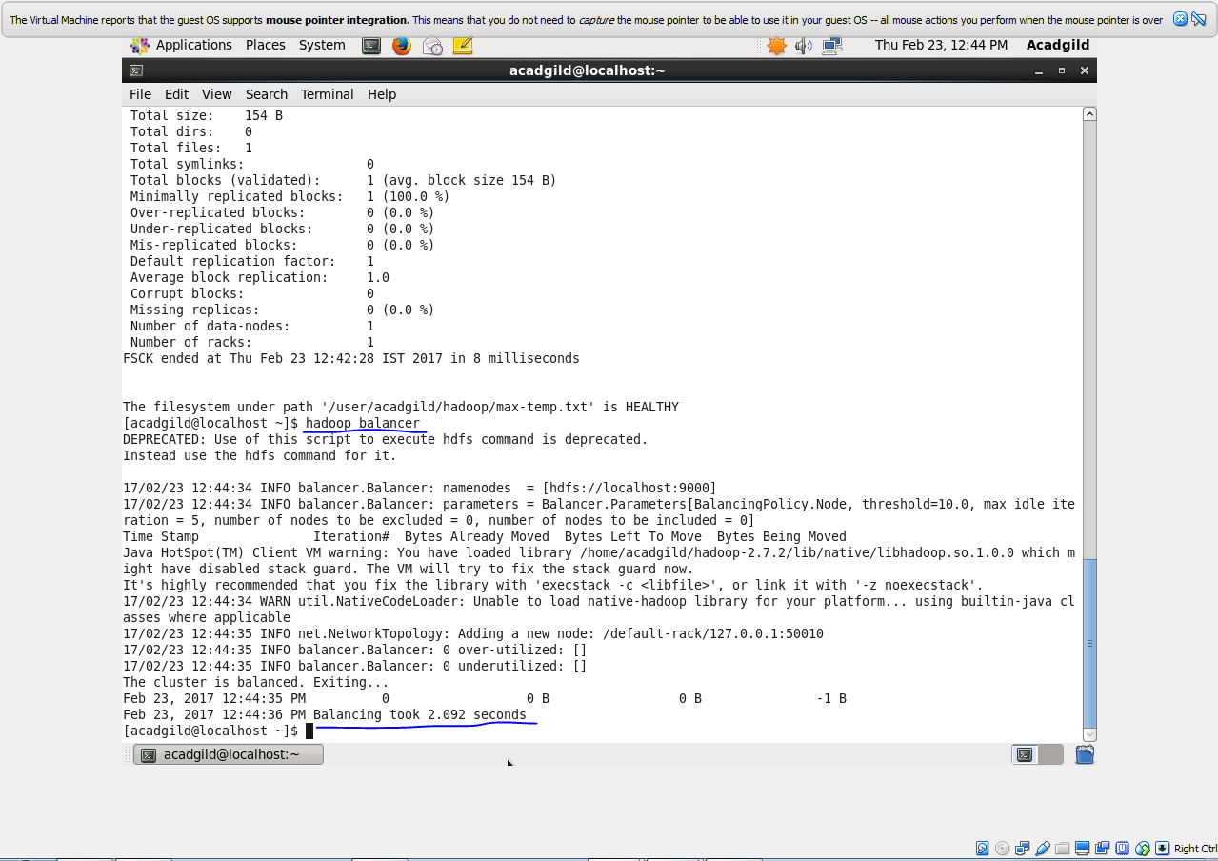

**11.Check Directory Space in HDFS**

The command will show the file size occupied by file inside cluster.

Syntax: **hadoop dfs -du -s -h </file path>**

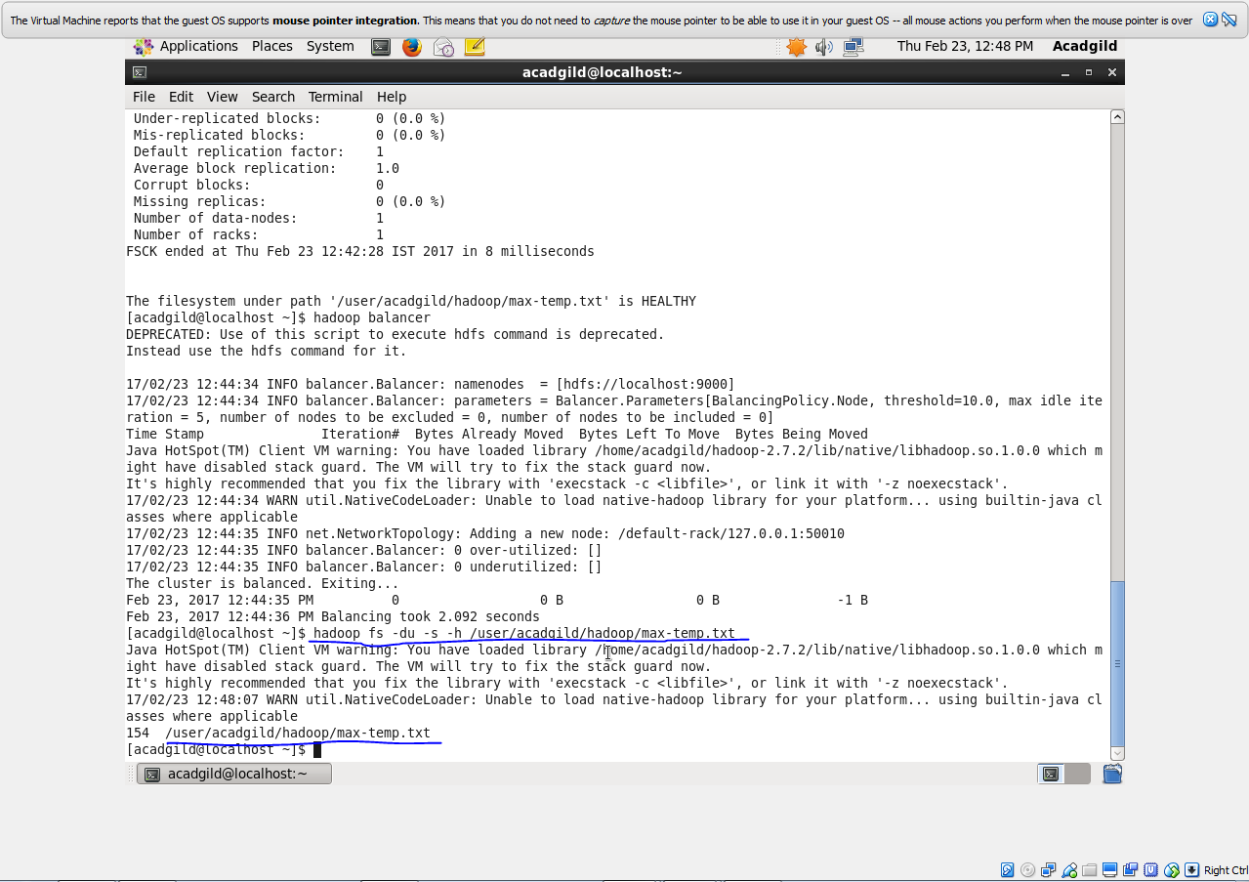

**12. List all the Hadoop File System Shell Commands**

The ‘fs’ command lists down all the shell commands of the Hadoop File System.  
Syntax: **hadoop fs [options]**

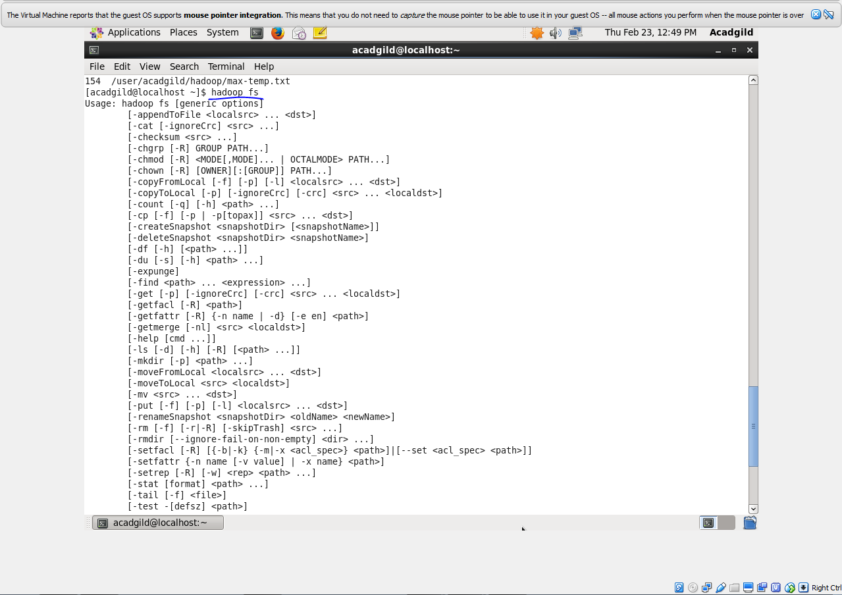

**13.Asking for Help**

The ‘help’ command is for asking for help or querying a particular question.

Command: **hadoop fs -help**

